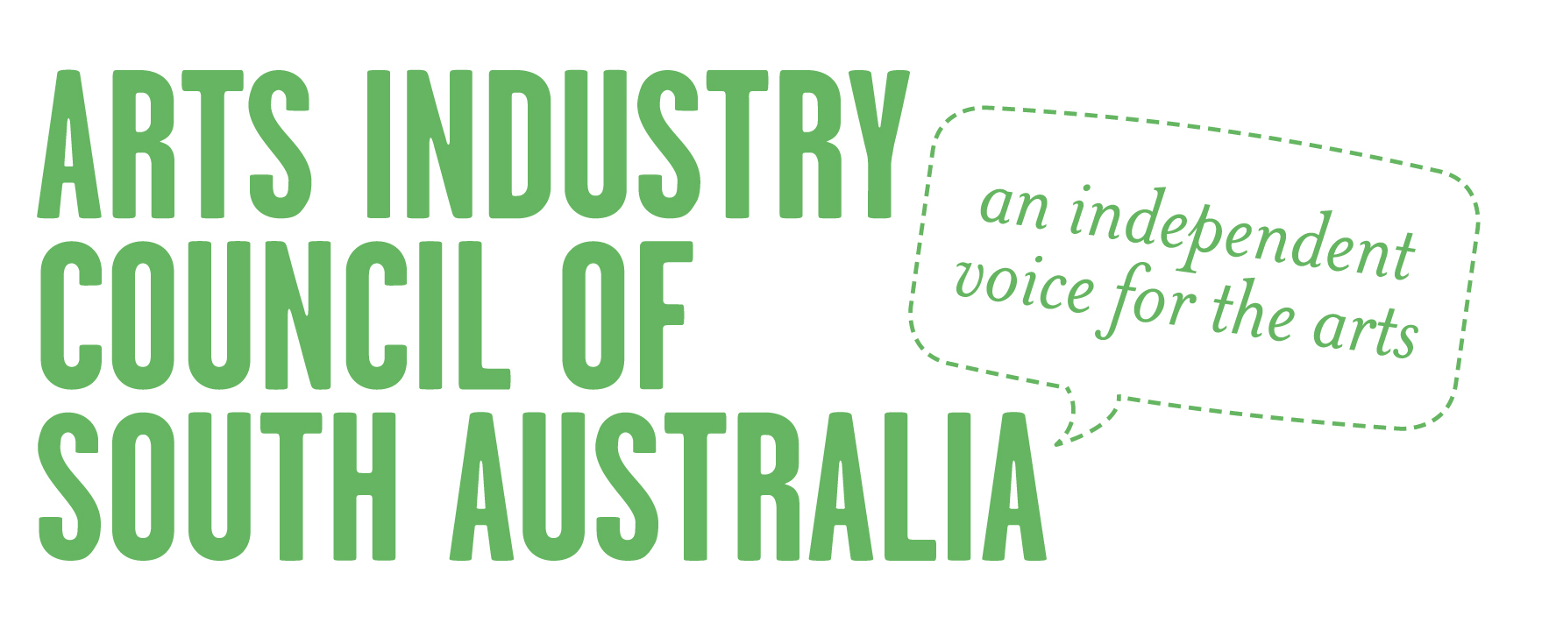
ANNUAL GENERAL MEETING

Wednesday 13 May 2020
5.00pm
Due to current social distancing rules in place for COVID-19 the Annual General Meeting will be held Via Zoom online video conference

Nomination Form: Election of Executive

The Executive consists of up to 10 elected members. An additional three financial members may be co-opted by the committee. Executive Committee terms are for two years and committee members may re-nominate at the Annual General Meeting.

Nominees and proposers must be either individual members or representatives of member organisations and must be financial at the time of the Annual General Meeting.

Please submit this nomination form together with a short bio and short description of reasons for wishing to join the AICSA Executive Committee. These will be published on the AICSA website in advance of the Annual General Meeting. Please submit by 5PM, MONDAY 11 MAY to Executive Officer info@aicsa.net.au

Nomination:

We, the undersigned, nominate …………………………………….………………………… as a candidate for election to the Executive of the Arts Industry Council of South Australia.

Name: ................................................ Signature: .………......................................…

Organisation (if organisation representative): ...................................................…..

Name: ................................................ Signature: .................................………......…

Organisation (if organisation representative): ..........................................………......

Consent:

I, …………………………………..……….……………..………….. consent to nomination as a candidate for election to the Executive of the Arts Industry Council (South Australia) Inc.

Signed: ………………………………………………………………………………………………….

Address: ………………………………………………………………………………………………….

Date: ....................................................................................................................

